**Lesson 1 (Ninja & Fruit)**

**3D Fruit Ninja**

1)First upload the fruit ninja background.

2)Upload the ninja sprite.



3)Make a new sprite called Fruits and upload different types of fruits within the sprite. Also add a bomb and explosion.

4)Go to the ninja sprite and add code to make it **glide randomly across the x-axis**.

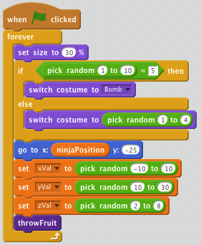5)Go to the fruits sprite and in a forever loop, **1 out of 10 times make the costume switch to the bomb** else **switch to random costumes**.

6)Now make the initial size to 30%.

7)Make the fruit follow the ninja.

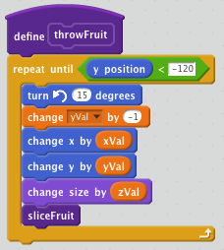8)Add x, y, z variables. Set them to random numbers. X -> (-10,10), y -> (10,10), z -> (2,8).

**Lesson 2 (Throw Fruit)**

1)Make a function called throwFruit.

2)Repeat until fruit hits the bottom.

3)It will spin and have gravity.

4)The x and y postitions will change and size too.

5)Make a sliceFruit for the next part.

**Lesson 3 (Slice Fruit)**

1)Make sure you have 1 explosion sprite that is big and a smaller one.

2)The fruit should slice when it touches the curser.

3)If the costume number is the bomb then we want it to stop and switch to the explosion costume.

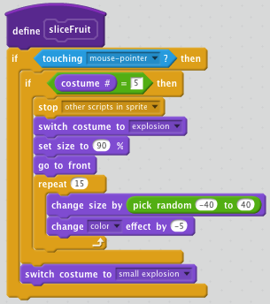

4)Then we want to set the size to 90% and go to front.

5)Do something cool like change size by a random number 15 times and change the color.

6)After switch to a costume of a small explosion.

**Lesson 4 (Scoring and Lives)**

1)Let’s make two new blocks called score and lives.

2)We want to make it change score everytime we slice a fruit.

3)Create a variable called score and set it to 0. **Place at when flag is clicked**.

4)Make the score increment everytime we hit a fruit.

5) Create a variable called lives and set it to 0. **Place at when flag is clicked**.

6)Change lives by -1 and if it is zero, it should broadcast a GameOver message.

7)Delete the clone

8)Create a game over sprite.

9)Hide it initially and when we reviece the GameOver message show it.

10)Code it to make the game over sprite appear in a cool way.